Religious Law

Introduction
- Syllabus
- CV and website
- Students
- Evaluation

Overview
- 10 online sessions on Mondays, 1600-1800 Central European Time
- Readings
- Written examination

Readings
Required Readings (http://u.pc.cd/Bso)
- Bauer, Nancy. “The State of Consecrated Life: Vita et Sanctitas Ecclesiae.” The Jurist 75 (2015): 71–108.
- Hereford, Amy. “Practical Guidelines for Aging Religious Institutes.” In Canon Law Society Proceedings, 220–60. Washington, D.C: Canon Law Society of America, 2015.
- Holland, Sharon, and Amy Hereford. “Canons 119.1-2, 127.1,3 , 167, 172.1.2, N220, 625.1, 627, 631-633: Virtual Meetings in Religious Life.” Roman Replies and CLSA Advisory Opinions, 2012, 69–76.
  - There is new guidance on this topic from CICLSAL, considering the pandemic.
- McDermott, Rose. Consecrated Life: Cases, Commentary, Documents, Readings. Alexandria, VA: Canon Law Society of America, 2006. p. 135ff
- McDermott, Rose. “The Vigilance of the Diocesan or Eparchial Bishop: Diocesan/Eparchial Right Institutes/Sui Iuris Monasteries/Hermits/Ascetics/Virgins/Widows.” Studies in Church Law 8 (2012): 141–74.
  - Note that there is new legislation on contemplative monasteries of nuns and on consecrated virgins, that effects their relationship with bishops. Otherwise the article is a fine analysis by a great canonist.
- Okoye, Agnes. “The Office of a Religious Superior in the Light of the Universal Law and the Proper Law of the Congregation of the Daughters of Divine Love.” Commentarium pro Religiosis et Missionariis 94, no. III–IV (2013): 207–27.
- Wijlens, Miriam. “Diminishing Human Resources for Leadership in Religious Institutes: A Canonical Reflection about the Situation in The Netherlands.” RCRI Bulletin, 2014, 4–20.
Recommended Readings - in addition to a general commentary on the canons:
- AAVV, NFVC. “Elementi Teologici e Canonici per La Riflessione Sulle Nuove Forme Di Vita Consacrata.” Commentarium pro Religiosis et Missionariis 96, no. I–II (2015): 51–73.
- Bauer, Nancy. “Profession by Votum or by Vinculum - Is One Bond Better than Another?” Studia Canonica 50 (2016): 359–82.
- ———. “The Religious Habit in Church Law from 1917 to the Present.” Studia Canonica 52 (2018): 45–80.
- Congregation for Institutes of Consecrated Life and Societies of Apostolic Life. Cor Orans – Implementing Instruction of the Apostolic Constitution Vultum Dei Quaerere on Women’s Contemplative Life. AAS 110 (2018). Rome: Libreria Editrice Vaticana, 2018.
- ———. Ecclesiae Sponsae Imago Instruction on the Ordo Virginum. AAS 110 (2018). Rome: Libreria Editrice Vaticana, 2018.
- Connors, Kelly. “The Role of the Major Superior with Particular Reference to Apostolic Women’s Religious Institutes in the United States.” Saint Paul University, 2011.
- Euart, Sharon. “Religious Sponsors, Ministry Leaders and Diocesan Bishops: Together in Communion.” RCRI Bulletin 18 (2017): 19–33.
- Hereford, Amy. “Canon 690: Reentering Religious Life.” Roman Replies and CLSA Advisory Opinions, 2017.
- ———. “Canon 803: Sponsorship of Catholic Schools.” Roman Replies and CLSA Advisory Opinions, 2014, 90–93.
- ———. “Members of Religious Institutes - Civil and Canonical Issues.” In Manual for Leaders in Religious Life, 5.1-40. Washington DC: RCRI, 2012.
- ———. “Practical Guidelines for Aging Religious Institutes.” Canon Law Society Proceedings, 220–60. Washington, D.C: Canon Law Society of America, 2015.
- ———. Religious Life at the Crossroads: A School for Mystics and Prophets. New York: Orbis Books, 2013.
- ———. Screening and Discernment Guide for Religious Life. 2nd ed. Saint Louis: Religious Life Project, 2018.
- ———. See I Am Making Something New: A Pastoral-Canonical Guidebook to New Religious Institutes, Diocesan Hermits, Consecrated Virgins and New Forms of Consecrated Life. St. Louis, MO: RLC, 2018.
- ———. “The Shape of Religious Life to Come.” Horizons 39, no. 2 (2014): 14–20.
- Hite, Jordan F., Sharon Holland, and Daniel J. Ward. A Handbook on Canons 573-746: Religious Institutes, Secular Institutes, Societies of the Apostolic Life. Collegeville MN: Liturgical Press, 1985.
- Holland, Sharon. “Select Issues in Religious Law: Admission, Separation, Approbation.” Canon Law Society of America Proceedings 44 (1982): 121–40.
- Martynyuk, Teodor. “Il Contributo Del CCEO Allo Sviluppo Del Monachesimo: Problemi e Prospettive.” Periodica 106, no. 2 (2017): 233–68.

Way of Life & Community of Faith

Canon 573
- §1 Life consecrated through
  - profession of the evangelical counsels
  - is a stable form of living, in which the faithful
  - follow Christ more closely under the
  - action of the Holy Spirit, and are
  - totally dedicated to God, who is
  - supremely loved.
- By a new and special title they are dedicated to seek
- the fullness of charity (caritatis perfectionem in the service of God's Kingdom,
  - for the honor of God,
  - the building up of the community and
  - the salvation of the world.
- They are a splendid sign in the Church,
- as they foretell the heavenly glory.

Law & Spirit
Spirit | Law
creative, free, charismatic, powerful, chaotic | orderly, predictable, stable, sustainable, right relationships
Romans 8:2 … through Christ Jesus the law of the Spirit who gives life has set you free from the law of sin and death.

Charism
- Founding Charism
  - Incarnates the Gospel in a particular time and place
    - Particular insight into Gospel Living
    - Experience of God, Community and Mission
  - Founding Generation
    - Five to ten people in a house
    - Ecclesial, Social, Political context
  - Founding story
- Living Charism
  - Ongoing gift based on the original inspiration
  - Each generation
  - Lives the Charism in a particular time and place
  - Discovers Charism's meaning in that time and place
  - Inspired by Founding Charism, answers new questions
- Experience of God, Community, and Mission (Community, Spirituality and Justice)

Office & Charism
- Intent to found institute:
  - Spirituality
  - Mission
  - Members
  - Constitution - Law
- Spiritual experience of founding generation:
  - Experience of God, Community and Mission
  - Expansion as people join
  - Ecclesiastical recognition

Hierarchy and Consecrated Life
- Both the hierarchical structure of the Church and institutes of consecrated life possess these two essential constituents.
- Now there are varieties of gifts, but the same Spirit…. strive for the greater gifts. 1 Cor 12
- Discernment of spirits. 1 Cor 12
- Test everything; hold fast to what is good … do not despise the gift of prophecy. 1 Thess 5

Balance Office & Charism
- Two orientations
  - Welcome the gifts of the Spirit
  - Coordinate these gifts
- Ongoing challenge
  - balance enables a flourishing of the Christian community
  - if charismatic gifts flow a little too freely, the community may suffer from a modicum of unruliness.
  - if officials control charism a little too strictly, within narrowly defined structures, may stifle the gift.
  - Apex of office between the First and Second Vatican Councils

Lumen Gentium

Chapter 2
- The Second Vatican Council sought to restore the balance.
- Office and Charism constitute the Church, are gifts of the Spirit.
- The holy people of God shares also in Christ's prophetic office.
- God distributes special graces among the faithful of every rank.
  - makes them fit and ready to undertake the various tasks and offices
  - for the renewal and building up of the Church.
- Judgment as to their genuinity and proper use belongs to those who are appointed leaders in the Church, to whose special competence it belongs,
  - not indeed to extinguish the Spirit, but
  - to test all things and hold fast to that which is good.

Chapter 5
- The counsels are a divine gift
- Church authority has the duty, under the inspiration of the Holy Spirit, of interpreting these evangelical counsels, of regulating their practice and finally to build on them stable forms of living. (no citation)
  - e.g by erection of an institute and the acceptance of its constitutions
- The hierarchy, following with docility the prompting of the Holy Spirit, accepts the rules presented by outstanding men and women and authentically approves these rules after further adjustments.
– Do not quench the Spirit. Do not treat prophecies with contempt but test them all; hold on to what is good. 1 Thess

1983 Code
… test … but do not quench….
- Canon 94: JP statutes define their purpose, constitution, government, and methods of operation.
- Canon 117: Competent ecclesiastical authority … approve the statutes of a juridic person.
- Canon 299: Competent authority reviews [private juridic person] statutes.
- Canon 304: Assn specifies qualifications for membership. and the name of the association.
- Canon 579: Diocesan bishops,… can erect institutes of consecrated life… Apostolic See… prior approval.
- Canon 584: The suppression of an institute pertains only to the Apostolic See. Also the only house: 616.2
- Canon 605: The approval of new forms of consecrated life is reserved only to the Apostolic See.

Perfectae Caritatis
- #19 When the question of founding new religious communities arises, their necessity or at least the many useful services they promise must be seriously weighed….
- Those areas where churches have recently established… which take into account the genius and way of life of the inhabitants and the customs and conditions of the regions….
- Sufficient resources for their ongoing life….

History

Meanings of History
- Your life
  - Curriculum Vitae
  - Memoir
- Long arc of history
  - Events
  - Evidence and meanings

History
- A parade of past, people, facts and events
  - begat, begat, begat,
- A story about the past for the present
- A story of competition and struggle
  - People and Peoples
  - East v West
  - Rome v Christianity
  - Christianity v Islam
- A story of movements and ideas
  - Philosophy, Mathematics, Communication, Technology, Enlightenment, Democracy, Science, Evolution, Relativity, Economics, Globalization, Post-modernism, Sociology
<html><iframe width=“560” height=“315” src=“https://www.youtube.com/embed/vGJ3KEuwSTg” frameborder=“0” allow=“accelerometer; autoplay; encrypted-media; gyroscope; picture-in-picture” allowfullscreen></iframe></html>

... a glass of wine
- Society/Community is wine
  - People, relations, values, groups
  - Family, Economy, Culture, Arts
- Law is a wine-glass
  - Embodies society’s values
  - Enables society to negotiate diversity and change
  - Gives structure to support social cohesion
- Metaphor breaks down

Global Monasticism
- 600 BC - Hindu Monasticism
  - Jain Monasticism
  - Buddhist Monks
- 100 BC - Essenes
- 350 AD - Celtic Monasticism
- 530 AD - Benedictines
<html><iframe width=“560” height=“315” src=“https://www.youtube.com/embed/AvFl6UBZLv4” frameborder=“0” allow=“accelerometer; autoplay; encrypted-media; gyroscope; picture-in-picture” allowfullscreen></iframe></html>

Timeline
- 2-300s Anthony, Pachomius, Amoun and Macarius, Jerome
- 400s Century - Augustine
- 500s Benedict, Columban, Augustine (of Canterbury)
- 1000s – Benedictine reforms
- 1100s – Crusades, Military Orders
- 1200 – Dominicans, Franciscans, Augustinians
- 15-1600s – Apostolic Congregations
- 1900s - VCII

Video Timelines
<html> <iframe width=“560” height=“315” src=“https://www.youtube.com/embed/CJdT6QcSbQ0” frameborder=“0” allow=“accelerometer; autoplay; encrypted-media; gyroscope; picture-in-picture” allowfullscreen></iframe> <iframe width=“560” height=“315” src=“https://www.youtube.com/embed/UY9P0QSxlnI” frameborder=“0” allow=“accelerometer; autoplay; encrypted-media; gyroscope; picture-in-picture” allowfullscreen></iframe> <iframe width=“560” height=“315” src=“https://www.youtube.com/embed/BJ0dZhHccfU” frameborder=“0” allow=“accelerometer; autoplay; encrypted-media; gyroscope; picture-in-picture” allowfullscreen></iframe> <p style=” margin: 12px auto 6px auto; font-family: Helvetica,Arial,Sans-serif; font-style: normal; font-variant: normal; font-weight: normal; font-size: 14px; line-height: normal; font-size-adjust: none; font-stretch: normal; -x-system-font: none; display: block;“ ><a title=“View History of Religious Life on Scribd” href=“https://www.scribd.com/doc/13323887/History-of-Religious-Life#from_embed” style=“text-decoration: underline;”>History of Religious Life</a> by <a title=“View 's profile on Scribd” href=“undefined#from_embed” style=“text-decoration: underline;”></a> on Scribd</p><iframe class=“scribd_iframe_embed” title=“History of Religious Life” src=“https://www.scribd.com/embeds/13323887/content?start_page=1&view_mode=scroll&show_recommendations=true&access_key=key-iordoclmy08hsusjhia” data-auto-height=“true” data-aspect-ratio=“null” scrolling=“no” width=“100%” height=“600” frameborder=“0”></iframe> </html>

Typology
- Consecrated Life (c573 – 606)
  - Diocesan Hermits (c603) - Besides institutes of CL… withdrawal… three evangelical counsels.
  - Diocesan Consecrated Virgins (c604) - …added to these forms of CL…virgins…. consecrated
  - New Forms (c605) approval … reserved to the Apostolic See
  - Religious Institutes (c607 – 709)
    - pronounce public vows and live a fraternal life in common
    - c589 – diocesan or pontifical institutes
    - c615 – autonomous monasteries
  - Secular Institutes (c710 – 730) (+15 esp vows, separation)
    - sacred bonds, evangelical counsels, living in the world
    - CMIS
Apostolic Oblates Apostolic Sodales | Jesus Caritas Fraternity
ASPIRING IN US | Lay Missionaries of the Passion
Blessed Trinity Missionary Institute | Madonna della Strada/Our Lady of the Way
Caritas Christi | Mission of Our Lady of Bethany
Catechists of the Heart of Jesus [Ukrainian] | Missionaries of the Kingship of Christ
Company of St. Paul | Notre-Dame de Vie
Company of St. Ursula | Oblate Missionaries of Mary Immaculate
Crusaders of Saint Mary | Opus Spiritus Sancti
DeSales Secular Institute | Pius X Society
Don Bosco Volunteers | Schoenstatt Family Institute
Family of Mary of the Visitation | Schoenstatt Fathers
Father Kolbe Missionaries of the Immaculata | Schoenstatt Sisters of Mary
Franciscan Missionaries of Jesus Crucified | Servite Secular Institute
Handmaids of Divine Mercy | Servitium Christi
Institute of the Heart of Jesus | Voluntas Dei Institute
- Societies of Apostolic Life (c731 – 746)(+58 esp, vows, formation, governance, separation)
  - apostolic purpose … living fraternal life in common
  - examples
- Ecclesial Movements
- Eastern Churches sui iuris
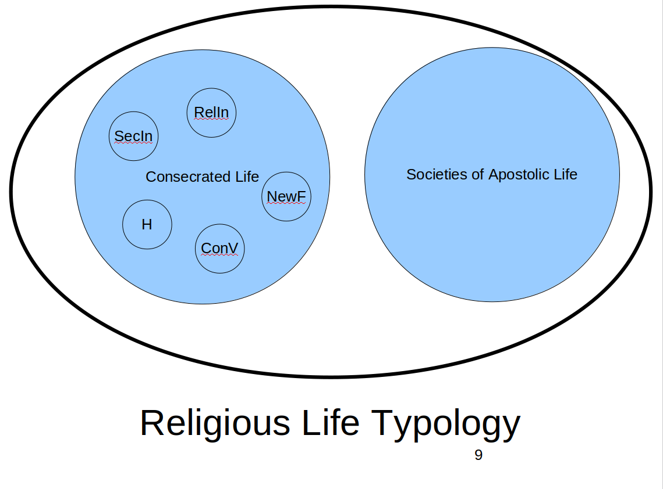
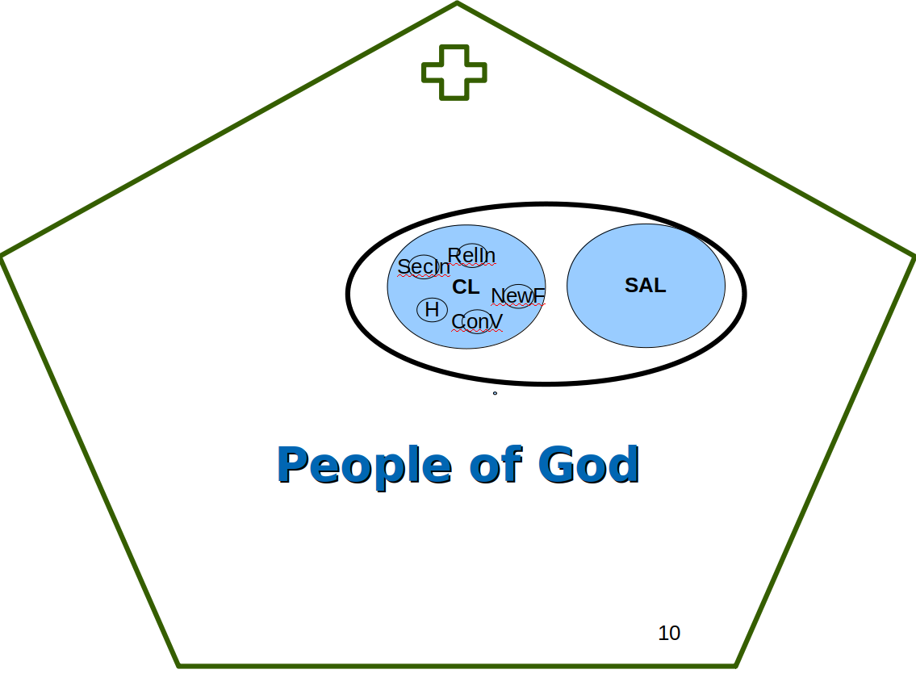
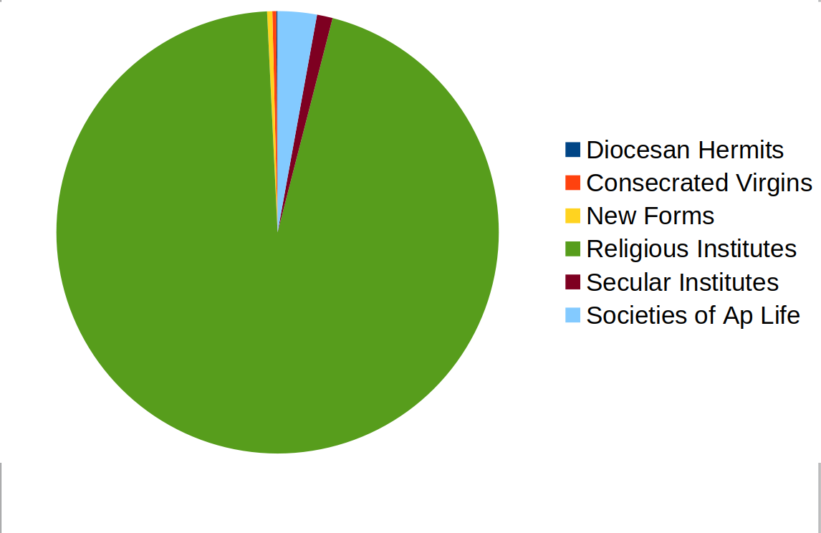

Consecrated Life
The rest of the course is found at this link.

Common Norms

Nature

Foundation, Merger, Division

Relation to CEA

Vows

Religious Institutes

Governance

Superiors & Councils

Chapters

Temporal Goods

Mission

Admission and Formation

Admission

Novitiate

Profession

Formation

Rights and Obligations

Departure and Process

Transfer

Departure

Dismissal

Hermits, Virgins & New Forms

Hermits

Virgins

New Forms

Secular Institutes

Societies of Apostolic Life

