Commissaries and Collaboration

by Amy Hereford, CSJ, JD, JCD

Scope of the Issue
- 75-90% of institutes/units will come to completion in the coming decades - 300-350 institutes

Historical Responses
- late 1900s - Perfectae caritatis ('65) #21 - “If it is possible, these should be combined with other more flourishing communities and monasteries whose scope and spirit is similar.”
- early 2000s - Covenant permitted a smaller institute to collaborate with a larger one on needs, and ultimately on governance.
  - Sample agreement
- Under these models, remaining institutes could have 5-10 institutes merging or affiliating
- Do these models allow for the flourishing of these remaining institutes? or the flourishing of religious life?

Indicia
- Motu Proprio Ecclesiae sanctae ('66) gave indicia of decline
  - the small number of religious in proportion to the age of the institute or the monastery,
  - the lack of candidates over a period of several years,
  - the advanced age of the majority of its members.
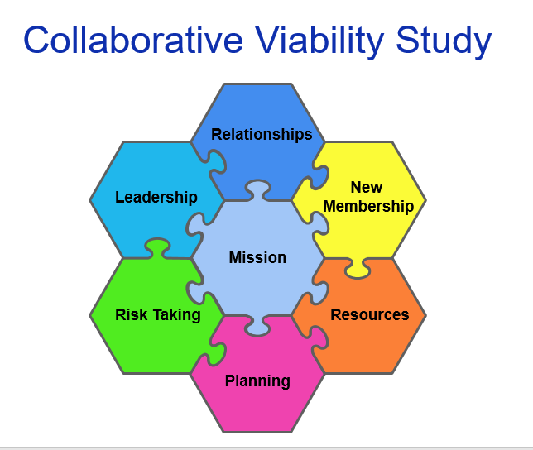

Particular Challenges
- Providing ongoing leadership for the institute.
- Providing care for aging members, in addition to health-care, this includes pastoral care and support of the members, those facing the challenges of aging and those moving out of full-time ministry, as well as those still in active ministry.
- Providing leadership in the sponsored ministries.

Cost of Eldercare
- 1986 NRRO formed by USCCB, CMSM, and LCWR to help address the funding shortfall
  - Collect and analyze data
  - Consulting with individual communities and developing best practices
  - Provide grants to communities

Completion of Life Journey
- Older and Grayer
- Two centuries of steady growth, sometimes outpacing population growth
 | 1776 | 1900 | 1965 | 2020
US Population | 2.5M | 76M | 191M | 330M
US Catholic Population | 50,000 | 7M | 46M | 76M
Religious Women | 200 | 25,000 | 185,000 | 40,000
- Dramatic decline - outside our national experience

Theology of Completion
- JB Metz / Karl Rahner
- Ars moriendi - Unlike the wider Church, religious institutes are not intended to live forever.
- The “gates of Hell will not prevail against [the church].”
- Religious institutes are gifts of the Spirit that blows where it will
- They have a life-span
- Death is an ending of the life-cycle, not failure or defeat
- We have a paschal theology.
- Only if we “cling desperately” to what is passing away, will the end be a defeat. (Metz)
- Our most important role as Christians is to say “yes” to God, and the final, most complete yes we are called to say is the yes to death. (Rahner)
- Our call is to come, to follow, to lay down our lives, and to surrender even in death to the call of God who is ever-present in our journey.

Journey to Completion
- Orderly transition of ministries
- Ensure the suitable care of its last members,
- Passing on of the spiritual patrimony of the institute
- Settling its legacy, and disposition of any remaining temporal goods.

Sponsorship
- Traditional Sponsorship
  - Missio - ensuring the Mission and Catholic Identity
  - Communio - ensuring Communion with the Church
- Transfering Sponsorship
- Ministerial Public Juridic Person
- Acknowledged as Catholic (schools)

Eldercare
- $9.8B deficit by 2034 (2016 NRRO/Mercer Human Resources Consulting)
- Two issues
  - Funding
  - Facility -
    - its oversight / management
    - pastoral care, family care
    - opportunities for collaboration
- Funding
  - Held in Operations, Fund or Trust
  - Trust $$ held by Trustee for Beneficiary
    - Trustee
      - Sisters or brothers, often leadership, can have non-member trustees
    - Beneficiary
      - Sick, aged and infirm sisters or brothers
  - To Trust or Not to Trust
    - 80s-90s: shield assets from liability or diversion
    - 10s-20s: estate planning: settle assets
      - for care
      - for legacy
        - traditional ministries
        - new and emerging needs
        - other units or other religious
  - Trust $$ held by Trustee for Beneficiary
    - Trustee
      - sisters or brothers, often leadership,
      - now consider a successor trustee
    - Beneficiary
      - sisters or brothers
      - legacy purpose

Administration
- Canonical Leadership historically serves as Board of Directors, oversees the administration and is often extensively involved in administration.
- Effective oversight by canonical leadership is critical
  - Administration can be entrusted to non-sisters/brothers,
  - Non-sisters/brothers can serve on the board of directors
  - Begin to support canonical leadership with staff and committees
  - These persons will continue to support when canonical leadership transitions
- Establish a right-sized administrative support system.
  - Opportunities for collaboration with other institutes/units
  - This would support elected leadership and later forms of canonical leadership

Community Assistance Ministry
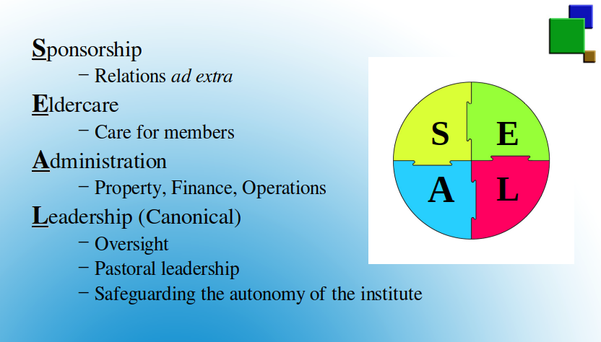
- Collaborative Community Assistance Ministries
- Regional collaboration for support with Eldercare and Administration
- Potential collaboration in supporting commissaries
- Importance and urgency of establishing as need is growing

Leadership
- Canonical Leadership
- Canon 623 To be validly appointed or elected to the office of superior, members must have been perpetually or definitively professed for an appropriate period of time, to be determined by their own law or, for major Superiors, by the constitutions.
- The canonical norm is one leader and two councilors, who may act collaboratively.
- When no sister or brother is capable or available for this ministry
- Turn to non-brother/sister as canonical leader
- Petition competent ecclesiastical authority (bishop / CICL)
  - Request appointment of commissary, canonical trustee, administrator superior - Rome has never preferred.
    - Competent - canonical, pastoral, administrative, financial, legal oversight
    - Disinterested - no financial or canonical interest, not a diocesan employee
    - Canon 318 §1: In special circumstances and where grave reasons require it, the ecclesiastical authority mentioned in can. 312 §1 can designate a trustee (commissarium) who is to direct the association for a time in its name.
  - Merge with another institute - Institutes rarely prefer this choice, retain identity, charism to the end.
  - Requires about 18 months to implement once a path is chosen.
- Alternate path for units: suppress governance
  - Establish an alternate plan for governance
    - No 'province governance'
    - Former provinces - by another name for clarity
    - Governed by elected or appointed brothers/sisters
      - Value of elected or appointed councilors
    - Who together form an expanded congregational council

Petition
- Petition from Community* (3-5 pages) – narrative is supported by data in appendices.
  - Request for Commissary
  - Reasoning
  - Brief History Leading to Petition
  - Consultation and Votes of Community
  - Nomination of Commissary
  - Financial Security
  - Conclusion
  - Signed by Canonical leader
- Appendices – tables and lists communicate the information more concisely
  - History of Community from foundation to present (1-2 pages)
  - Sisters, ages, living arrangements, and ministry (1 page)
  - Timeline of Meetings / Decision with Community and Commissary (1-2 pages)
  - Council Minutes of Community Resolution for the petition (1 page)
  - USCCB NRRO Retirement Needs Analysis Report
- Letters of Support
  - Commissary (1-2 pages)
  - Commissary’s Community (1 page)
  - Bishop (1-2 pages)

Legacy
- Canon 634 - Religious Institutes have the “capacity to acquire, possess, administer and alienate temporal goods.”
- Canon 123 - On the extinction of a public juridical person,
  - the arrangements for its patrimonial goods and rights, and for its liabilities,
  - are determined by law and statutes.
  - If these do not deal with the matter,
  - the arrangements devolve upon the next higher juridical person,
  - always with due regard for the wishes of the founders or benefactors and for acquired rights.
- Canon 584 - The suppression of an institute pertains only to the Apostolic See; a decision regarding the temporal goods of the institute is also reserved to the Apostolic See.
  - Holy See generally respects the stated dispositions of an institute
  - For the historical ministries of the institute
  - In keeping with the life and mission of the institute
  - The fund for elderly religious,
  - An institute that supports it in the declining years.
- Trust
  - Legacy clause in a retirement trust
  - Legacy trust

Planning
- What assets does the group have, financial, real estate, trusts, etc? And approximate value.
- What is the current purpose or use of those assets?
- What would be the legacy use of those assets? And what might the timeline look like?
- What is the best way to ensure that the assets are used for the current purpose, then dedicated to the legacy purpose?
- Since there is quite a variation in those answers, the way of moving forward could be quite different.
 | Asset | Value | Use/Purpose | Legacy
Sisters Inc | Land | $$$ | Sisters
Sisters Inc | Land | $$$ | Ministry
Sisters Inc | Investments | $$$
Trust |  | $$$ | Sisters
Retirement Facility |  | $$$ | Sisters
Ministry |  | $$$ | Ministry

Take Aways
- Plan ahead
- Be realistic
- Collaborate
- You're not alone
- Be generous and trust

Bibliography
Hereford, Amy. Beyond the Crossroads: Religious Life in the 21st Century. New York: Orbis Books, 2019.
———. “Canon 580: Aggregation and Covenants.” Roman Replies and CLSA Advisory Opinions, 2012, 83–86.
———. “Canon 584: Merging of Institutes.” Roman Replies and CLSA Advisory Opinions, 2011, 90–93.
———. “Canon 625: Minimum Numbers for Governance in a Religious Institute.” Roman Replies and CLSA Advisory Opinions, 2016.
———. “Canon 634: Legacy Distributions for Religious Institutes.” Roman Replies and CLSA Advisory Opinions, 2018.
———. “Charitable Trusts Twenty Five Years Later.” Legal Bulletin 73 (2002): 17–37.
———. “Congregational Legacy Trust.” RLC Newsletter 17, no. 4 (2017): 1–4.
———. “Ministerial Public Juridic Person.” RLC Newsletter 17, no. 3 (2017): 1–4.
———. Navigating Change: The Role of Law in the Life-Cycle of a Religious Institute. St. Louis, MO: Religious Life Project, 2015.
———. “Practical Guidelines for Aging Religious Institutes.” In RCRI Bulletin, 4–20. Silver Spring, MD: RCRI, 2015.
———. “Religious Institutes Coming to Completion and Their Legacy.” Presentation at RCRI, October 3, 2019, Dallas Texas
———. “Transitioning Leadership.” RLC Newsletter 17, no. 2 (2017): 1–4.
———. “Transitioning Sponsorship.” RCRI Bulletin 17 (2017): 5–18.
Sign up for RLC Newsletter (Religious Law and Consultation).

